**Express AI**

Presented by Team Apex

**Team Apex**

**Bachelor of Computer Application**

Under the guidance of an assistant professor

**Dr. Rashmi Shekhar**



**Amity Institute of Information Technology**

**Amity University**

**Patna**

**2024-27**

**Our Team Members-**

Kumar Sahil

Bittu Kumar Ravi Ronak

**Abstract:**

Visually impaired individuals often struggle to access and understand the emotional tone of content on web pages. Current software solutions mainly focus on reading the text aloud without conveying the writer's emotional intent. This project introduces Express AI, a browser extension developed by Team Apex, which aims to enhance the reading experience for visually impaired users. Unlike traditional text-to-speech tools, Express AI integrates advanced artificial intelligence models to analyze the emotional context of web content. This allows the extension to dynamically adjust the voice output, conveying both the text and the emotional tone behind the words. For example, a sentence expressing excitement is read with enthusiasm, while a serious statement is delivered in a calm and thoughtful tone.

Express AI also incorporates sound effects to enrich the user experience further, helping both visually impaired and sighted users connect more deeply with online content. By providing a more engaging and meaningful reading experience, this extension ensures that individuals can enjoy a dynamic, nuanced, and context-aware auditory experience, facilitating improved comprehension and emotional connection with the content.

**Express AI – Project Report**

**Table of Contents**

**Chapter 1: Introduction** 1

**Chapter 2: Requirements And Analysis** 2

**Chapter 3: Survey Of Technology** 3

**Chapter 4: Project Design** 4

**Chapter 5: System Analysis** 5

**Chapter 6: System Design** 6

**Chapter 7: Implementation And Testing** 7

**Chapter 8: Product Design** 8

**Chapter 9: Results And Discussion** 9

**Chapter 10: Conclusion And Future Work** 10

**Chapter 11: Estimated Budget for Express AI** 11

**Chapter 12: References and Team Information** 12

# **Chapter 1: Introduction**

In today’s digital age, visually impaired individuals face significant challenges in reading and understanding text-based content available on web pages. While many existing software solutions assist in reading digital text aloud using text-to-speech (TTS) technology, they often fail to capture the emotions or intent conveyed by the writer. This results in a reading experience that lacks depth and engagement, making it difficult for visually impaired users to fully comprehend the nuances and emotional tone behind the words.

To address this issue, *Express AI* is being developed as an advanced browser extension aimed at enhancing the digital reading experience by incorporating emotional intelligence into text-to-speech technology. Unlike traditional TTS tools that read text in a neutral, monotonous voice, *Express AI* intends to analyze the emotional context of the text and adjust the voice output accordingly. This will allow users to experience web content with the appropriate emotional tone, making the content more engaging and meaningful.

However, as the project is currently in the early development phase, the first version of *Express AI* only includes a basic text-to-speech function without any emotional tone adjustments. Future versions will integrate AI-based sentiment analysis to dynamically modify the speech output to match the writer’s emotions. The long-term vision for *Express AI* is to create an innovative and accessible tool that significantly improves the way visually impaired individuals interact with digital content.

# **Chapter 2: Requirements And Analysis**

The development of *Express AI* involves multiple technical and functional requirements to ensure its effectiveness in delivering an emotionally aware text-to-speech experience. These requirements can be categorized into:

**1. Functional Requirements:**

* **Web Page Text Extraction:** The extension must efficiently extract and process text from any web page without altering the content structure.
* **Text-to-Speech Conversion:** The extracted text must be converted into audible speech using an advanced TTS engine.
* **Emotion Analysis (Future Feature):** AI models must be integrated to analyze the emotional context of the extracted text.
* **Voice Modulation (Future Feature):** The system should adjust the speech tone based on the detected emotions to match the original intent of the content.

**2. Technical Requirements:**

* **Browser Compatibility:** The extension should support popular web browsers like Google Chrome, Mozilla Firefox, and Microsoft Edge.
* **Natural Language Processing (NLP):** AI-based NLP algorithms will be required to assess the sentiment of the text.
* **Speech Synthesis API:** Integration with existing TTS engines like Google Cloud Text-to-Speech or Amazon Polly.

At the moment, *Express AI* only fulfills the text extraction and text-to-speech conversion requirements. Emotional analysis and voice modulation are planned for future updates.

# **Chapter 3: Survey Of Technology**

The research for *Express AI* includes an in-depth analysis of existing text-to-speech solutions and advancements in AI-driven sentiment analysis.

**1. Existing Text-to-Speech Solutions:**

Several companies provide high-quality text-to-speech services, including:

* **Google Text-to-Speech:** Offers natural-sounding speech synthesis with multiple voice options.
* **Amazon Polly:** Converts text into lifelike speech using deep learning models.
* **Microsoft Azure Speech Services:** Provides customizable voice synthesis with support for various emotions but not real time.

While these services provide advanced TTS capabilities, they do not focus on adapting speech tone based on emotional context, which is the core feature planned for *Express AI*.

**2. Sentiment Analysis Techniques:**

To incorporate emotional intelligence, *Express AI* will leverage AI-powered sentiment analysis techniques, such as:

* **Lexicon-Based Analysis:** Matching words against predefined emotion databases.
* **Machine Learning Models:** Training AI to classify emotions from text.
* **Deep Learning Approaches:** Using neural networks to predict emotional tones with high accuracy.

As of now, sentiment analysis is not yet implemented in *Express AI*, but future updates will include these features to enhance user experience.

# **Chapter 4: Project Design**

The *Express AI* extension is designed using modular architecture to ensure scalability and ease of development. The system is divided into the following modules:

1. **Text Extraction Module:** Extracts text from web pages dynamically without altering their structure.
2. **Speech Synthesis Module:** Converts the extracted text into audible speech using an integrated TTS engine.
3. **Emotion Detection Module (Future Update):** AI algorithms will analyze the emotional tone of the text.
4. **Voice Modulation Module (Future Update):** Adjusts the speech output to reflect the detected emotions.
5. **User Interface:** Allows users to interact with and customize the extension settings.

Currently, the system only includes text extraction and speech synthesis, while emotion detection and voice modulation are under development.

# **Chapter 5: System Analysis**

**1. Current Limitations:**

* The system only provides basic TTS functionality without emotional variation.
* No sentiment analysis has been integrated yet.
* Speech output is neutral and does not change tone based on content.

**2. Future Enhancements:**

* Implementation of AI-based sentiment analysis for real-time emotion detection.
* Integration of voice modulation reflects emotions dynamically.

At present, *Express AI* can assist visually impaired users with basic text-to-speech, but its full potential will be realized once emotional tone detection is implemented.

# **Chapter 6: System Design**

**1. System Components:**

* **Web Page Analyzer:** Scans and extracts text content.
* **TTS Engine:** Converts text to speech.
* **AI Sentiment Analyzer (Future Feature):** Determines the emotion behind the text.
* **Speech Tone Modifier (Future Feature):** Adjusts speech output dynamically.

**2. Workflow:**

1. The extension extracts text from the webpage.
2. The text is processed and sent to the TTS engine.
3. The engine generates a neutral audio output.
4. (Future) The AI module analyzes emotions and modifies speech tone.

Currently, only steps 1–3 are functional, while step 4 is planned for future updates.

# **Chapter 7: Implementation And Testing**

**1. Implementation:**

* Developed as a Chrome extension using JavaScript.
* Uses Google’s TTS API for speech synthesis.
* Allows users to select text and listen to it in a neutral voice.

**2. Testing:**

* Accuracy of text extraction tested on various web pages.
* Speech output clarity tested across different browser environments.
* Future testing will focus on sentiment analysis and voice modulation.

# **Chapter 8: Product Design**

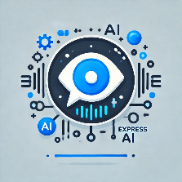

**Express AI**

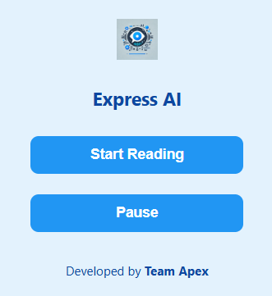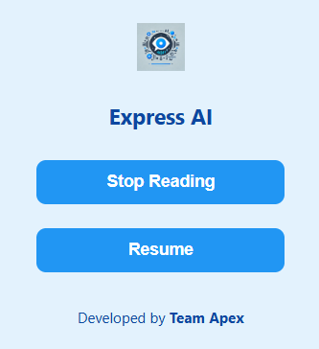

**User Interface (UI)**

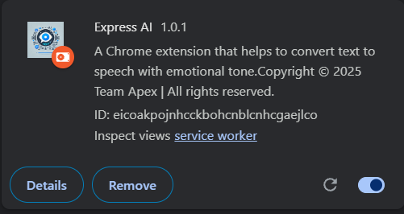

**Extension Information Card**

# **Chapter 9: Results And Discussion**

The current version of *Express AI* successfully converts text from web pages into speech. However, it does not yet capture emotional tones, limiting its effectiveness in conveying the writer’s intent. User feedback highlights the need for emotional intelligence integration to improve comprehension and engagement.

**For More Information Visit :-**

https://github.com/TeamApexOfficial/ExpressAIWebExtension

# **Chapter 10: Conclusion And Future Work**

*Express AI* is designed to bridge the gap between traditional text-to-speech technology and emotionally aware speech synthesis. While the current version only supports basic TTS, future updates will introduce AI-driven emotion analysis and dynamic voice modulation. The next steps include:

* Implementing sentiment analysis algorithms.
* Training AI models for accurate emotion detection.
* Enhancing voice modulation to match different emotional contexts.

These advancements will make *Express AI* a groundbreaking tool for visually impaired individuals, enabling a richer and more engaging online reading experience.

# **Chapter 11: Estimated Budget for Express AI**

|  |  |
| --- | --- |
| Category | Price |
| AI API + Firebase | ₹15,000 |
| Crome Web Store Listing | ₹540 (one time) |
| Domain Name | ₹700 |
| Mail Server | ₹2,000 |
| GitHub | ₹0 |
| Total | **₹18,240 for 1st year** |

# **Chapter 12: References and Team Information**

**01. References**

* Chat GPT and Other Generative AI Tools
* W3schools
* MDN Docs
* YouTube
* GitHub

**02. Team Information**

|  |  |  |
| --- | --- | --- |
| Name | Course | Enrollment No. |
| Kumar Sahil | BCA | A45304824162 |
| Bittu Kumar | BCA | A45304824153 |
| Ravi Ronak | BCA | A45304824154 |

**Copyright © 2025 Team Apex | Licensed Under Apache 2.0 License**